DVWA Project

**Authorization Bypass**: Security vulnerability that allows an attacker to access functionality or data that they are not authorized to access

**Low**: No related code

**Medium**:

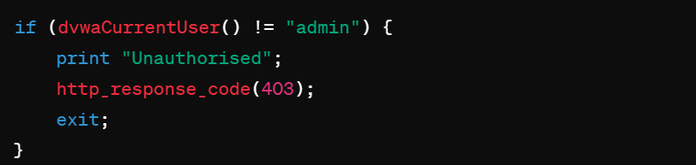

* + **Improvement**: Includes a server-side check to ensure that only users with the “admin” role can access the page
  + **How it works**: Checks if the user is not “admin”, if so, responds with an “Unauthorized” message and a 403 HTTP status code, effectively blocking unauthorized access

**High**: No changes made

**Impossible**: No changes made

**Brute Force**: The attacker uses numerous hit-or-miss attempts to gain access to an account

**Low**: No related code

**Medium**:



**High**:



**Impossible: ok**

